Mat E 272
Fall 2001 - Lecture 1

General information

Course description: Mat E 272. Principles of Materials Science and Engineering
(2-0) Cr. 2. F.S.SS. Prereq: Chem 167 or 177. Introduction to the structure of metals, polymers and ceramics. Crystal structure and imperfections in metals. Diffusion, mechanical properties, and failure mechanisms. Phase equilibrium diagrams and heat treatment principles for steels, cast irons, and aluminum alloys. Corrosion and electrical properties. Engineering applications.

Instructor: Bruce Cook cook@iastate.edu
Office: 253 Spedding 4-9673

Office Hours: (in 253 Spedding): Tue & Thurs 3:30 - 5:00, Fri 11:00 - 12:00
other times arranged as needed

Text: W.D. Callister, Jr., Materials Science and Engineering an Introduction, 5th edition

Grading: Grade weighting:
The 10 homework assignments together count 30%

The midterm exam counts 30%
The final exam counts 40%

Internet: Occasionally, helpful information related to the course will be posted on the Mat E 272 web site at http://www.mse.iastate.edu/mate272/

Course Objectives: The objectives of Mat E 272 are to give the student the ability to:

(1) predict physical properties of a material based on the type of bonding present (covalent, ionic, metallic, and/or van der Waals) and the presence of any of the several types of defects common in condensed matter

(2) use knowledge of the crystal structure (primarily BCC & FCC) of a metal to make general predictions about the metal’s ability to plastically deform

(3) calculate the extent of diffusion-driven composition changes based upon composition, time, and temperature

(4) predict the microstructure of a material comprised of two constituents (e.g. Fe and C or ZrO2 and CaO) given the binary phase diagram and thermal history of the material

(5) use a steel’s time-temperature-transformation diagram to specify a suitable heat treatment to produce any of the major microstructures in steel (pearlite, bainite, martensite, or tempered martensite)

(6) specify an appropriate heat treatment to precipitation harden a binary alloy given the phase diagram for that alloy

(7) recognize the basic causes of metallic aqueous corrosion and oxidation and design simple systems to minimize corrosion damage

(8) use knowledge of the electronic structure of materials to make general predictions about the material’s ability to conduct electricity

The bottom line: To understand the relationship between the following four factors:

processing → structure → properties → performance

Milestone Schedule:

Week No. | Dates | Topic | Homework* (Due Friday: 12:00 noon) | Reading from Callister
1 | Aug 28 & 30 | Intro & Atomic Bonding | none | Chap. 1, 2
2 | Sep 4 & 6 | Crystal Structures | Set 1 | pp. 30-53 (except HCP planes/dir'ns), 58-59
3 | Sep 11 & 13 | Crystal Defects | Set 2 | Chap. 4
4 | Sep 18 & 20 | Diffusion | none | Chap. 5
5 | Sep 25 & 27 | Mechanical Properties of Metals | Set 3 | Chap. 6
6 | Oct 2 & 4 | Dislocations/Strengthening | Set 4 | Chap. 7
7 | Oct 9 & 11 | Midterm Exam (Oct 9)  Phase Diagrams (Oct 11) | none | Chap 9.1-9.11
8 | Oct 16 & 18 | Fracture, Fatigue, & Creep | Set 5 | Chap. 8  (exclude Sec. 8.10)
9 | Oct 23 & 25 | Polymers | Set 6 | Chap 15 (exclude 15.8-9)  Chap. 16.1-10
10 | Oct 30, Nov 1 | Phase Transformations / Steel | Set 7 | Chap. 9.13-15, Chap. 10.1-5
11 | Nov 6 & 8 | Steel | Set 8 | Chap. 10.6-9, Chap. 11
12 | Nov 13 & 15 | Cast Iron, Ppt. Hardening, Nonferrous Alloys | Set 9 | Chap. 12
 |  | THANKSGIVING BREAK
13 | Nov 27 & 29 | Ceramic Materials | none | Chap. 13,  Chap. 14.1-5, 14.9
14 | Dec 4 & 6 | Electrical Properties | Set 10 | Chap. 19.1-14
15 | Dec 11 & 13 | Corrosion | none | Chap. 18
16 | Fri , Dec 21, 9:45 – 11:45 | Final Exam

* Late homework is reduced in score 10% for each day late, unless excused by instructor. Homework submitted more than 1 week late will not be graded.

Motivation: why study Materials Science?

‘Important to understand capabilities and limitations of materials:

the following are just a few examples of catastrophic failure caused by a lack of fundamental understanding of materials, their properties, and failure modes.

- Liberty ships (WWII)

D-B-T in BCC Fe (metal)
- Challenger (1986)
failure of an O-ring seal (polymer)
- Hyatt Regency (KC) walkway collapse (1981)
overstressed steel support rods (underdesigned)
- Alaska MD-80 crash (1999)
excessive wear on stabilizer jackscrew
- United DC-10 crash (Sioux City, IA) (1989)
inclusion and cracking in primary #2 engine turbine blade
- Tacoma Narrows Bridge Collapse (1940)
poor design – insufficient crosswind stiffening
- de Havilland Comet (first commercial jet) (1954 – 55)
metal fatigue, aggravated by high stresses around rivet holes near window openings

Materials science help us to design better components, parts, devices, etc.

- how do you make something stronger or lighter?
- how do elements come together to form alloys?
- why do some materials have vastly different properties than others?
why is graphite soft while diamond is hard?

- It’s interesting and helps to make you a more informed person

Our understanding of the building blocks of materials from ~ 300 BC to ~ 1800:

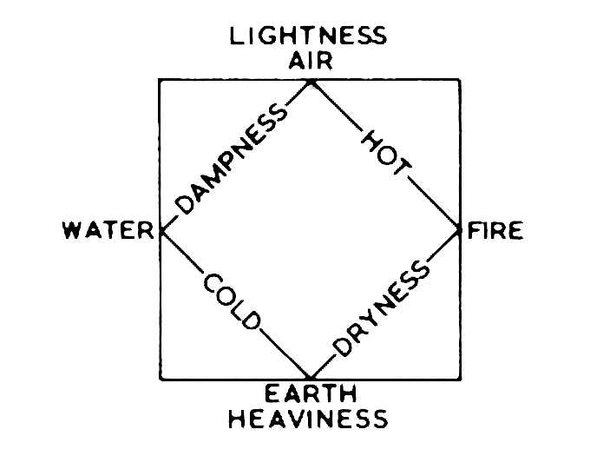

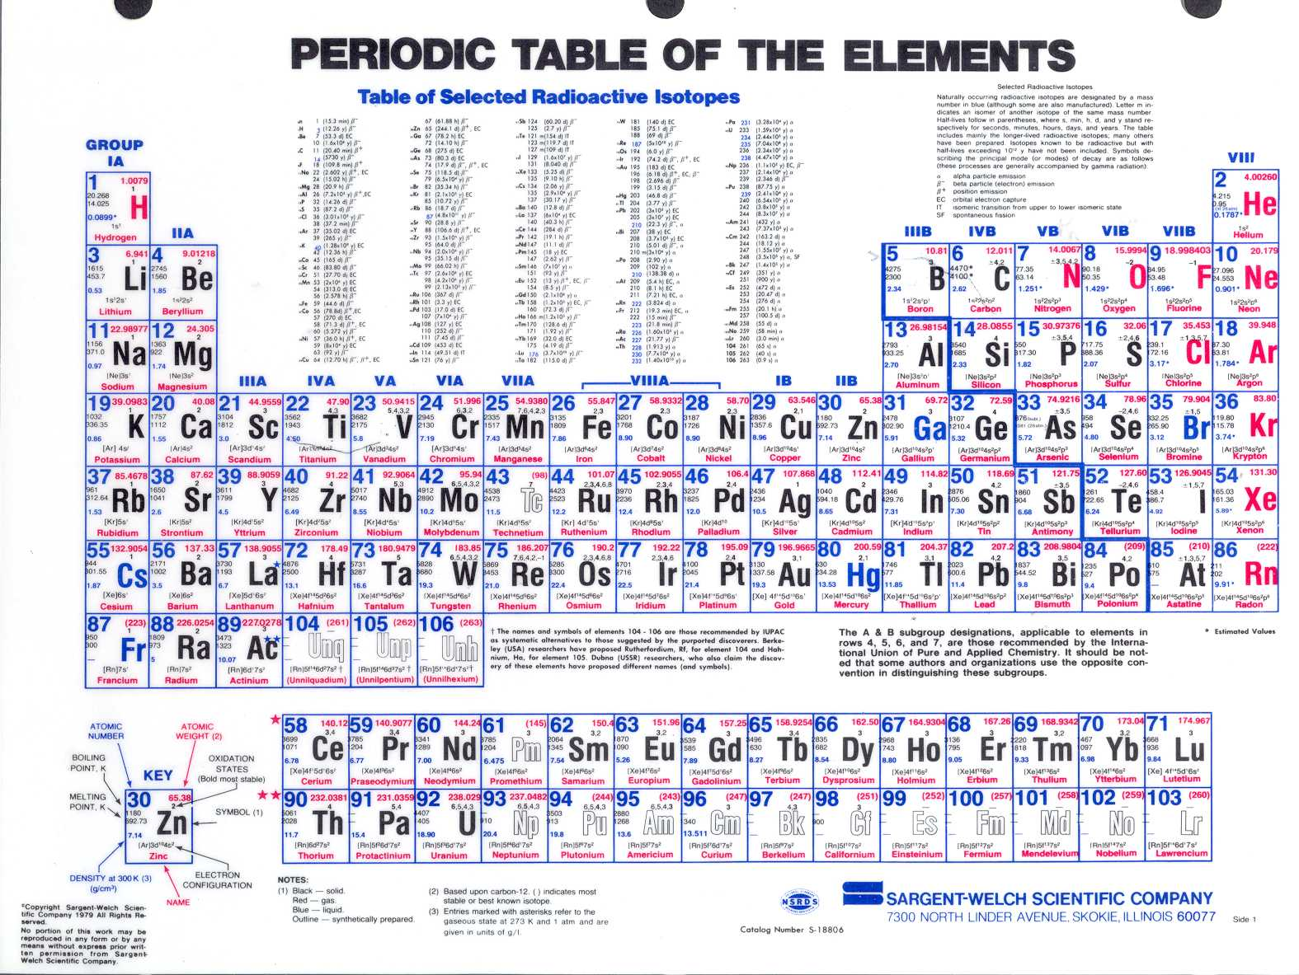

Elements are classified according to electron configuration

most elements can be classified as “metals” and are electropositive (able to give up electrons to become positively charged ions). In contrast, elements on the right-hand side of the table are termed electronegative, because they have a tendency to accept electrons.

all elements in a given column have similar valence structures (and, to a certain extent, similar chemical behavior)

Group # | Elements | Group name & characteristics
VIII (or 0) | He, Ne, Ar, Kr, Xe, Rn | noble gases; filled valence shells, highly stable
VIIA | F, Cl, Br, I, At | halogens; electron deficient, highly reactive (non-metals)
VIA | O, S, Se, Te, Po | chalcogenides; non-metals (except polonium)
VB | N, P, As, Sb, Bi | pnictides; non-metals (some semiconductors)
IVB | C, Si, Ge, Sn, Pb | mostly semiconductors
IA | H, Li, Na, K, Rb, Cs, Fr | alkali metals; one excess electron over filled shell
IIA | Be, Mg, Ca, Sr, Ba, Ra | alkaline earth metals; two additional electrons
IIIA – IIB | e.g., Cu, Ag, Cr, V, Fe | transition metals; properties determined by d electrons

A look at some differences between three main classes of materials:
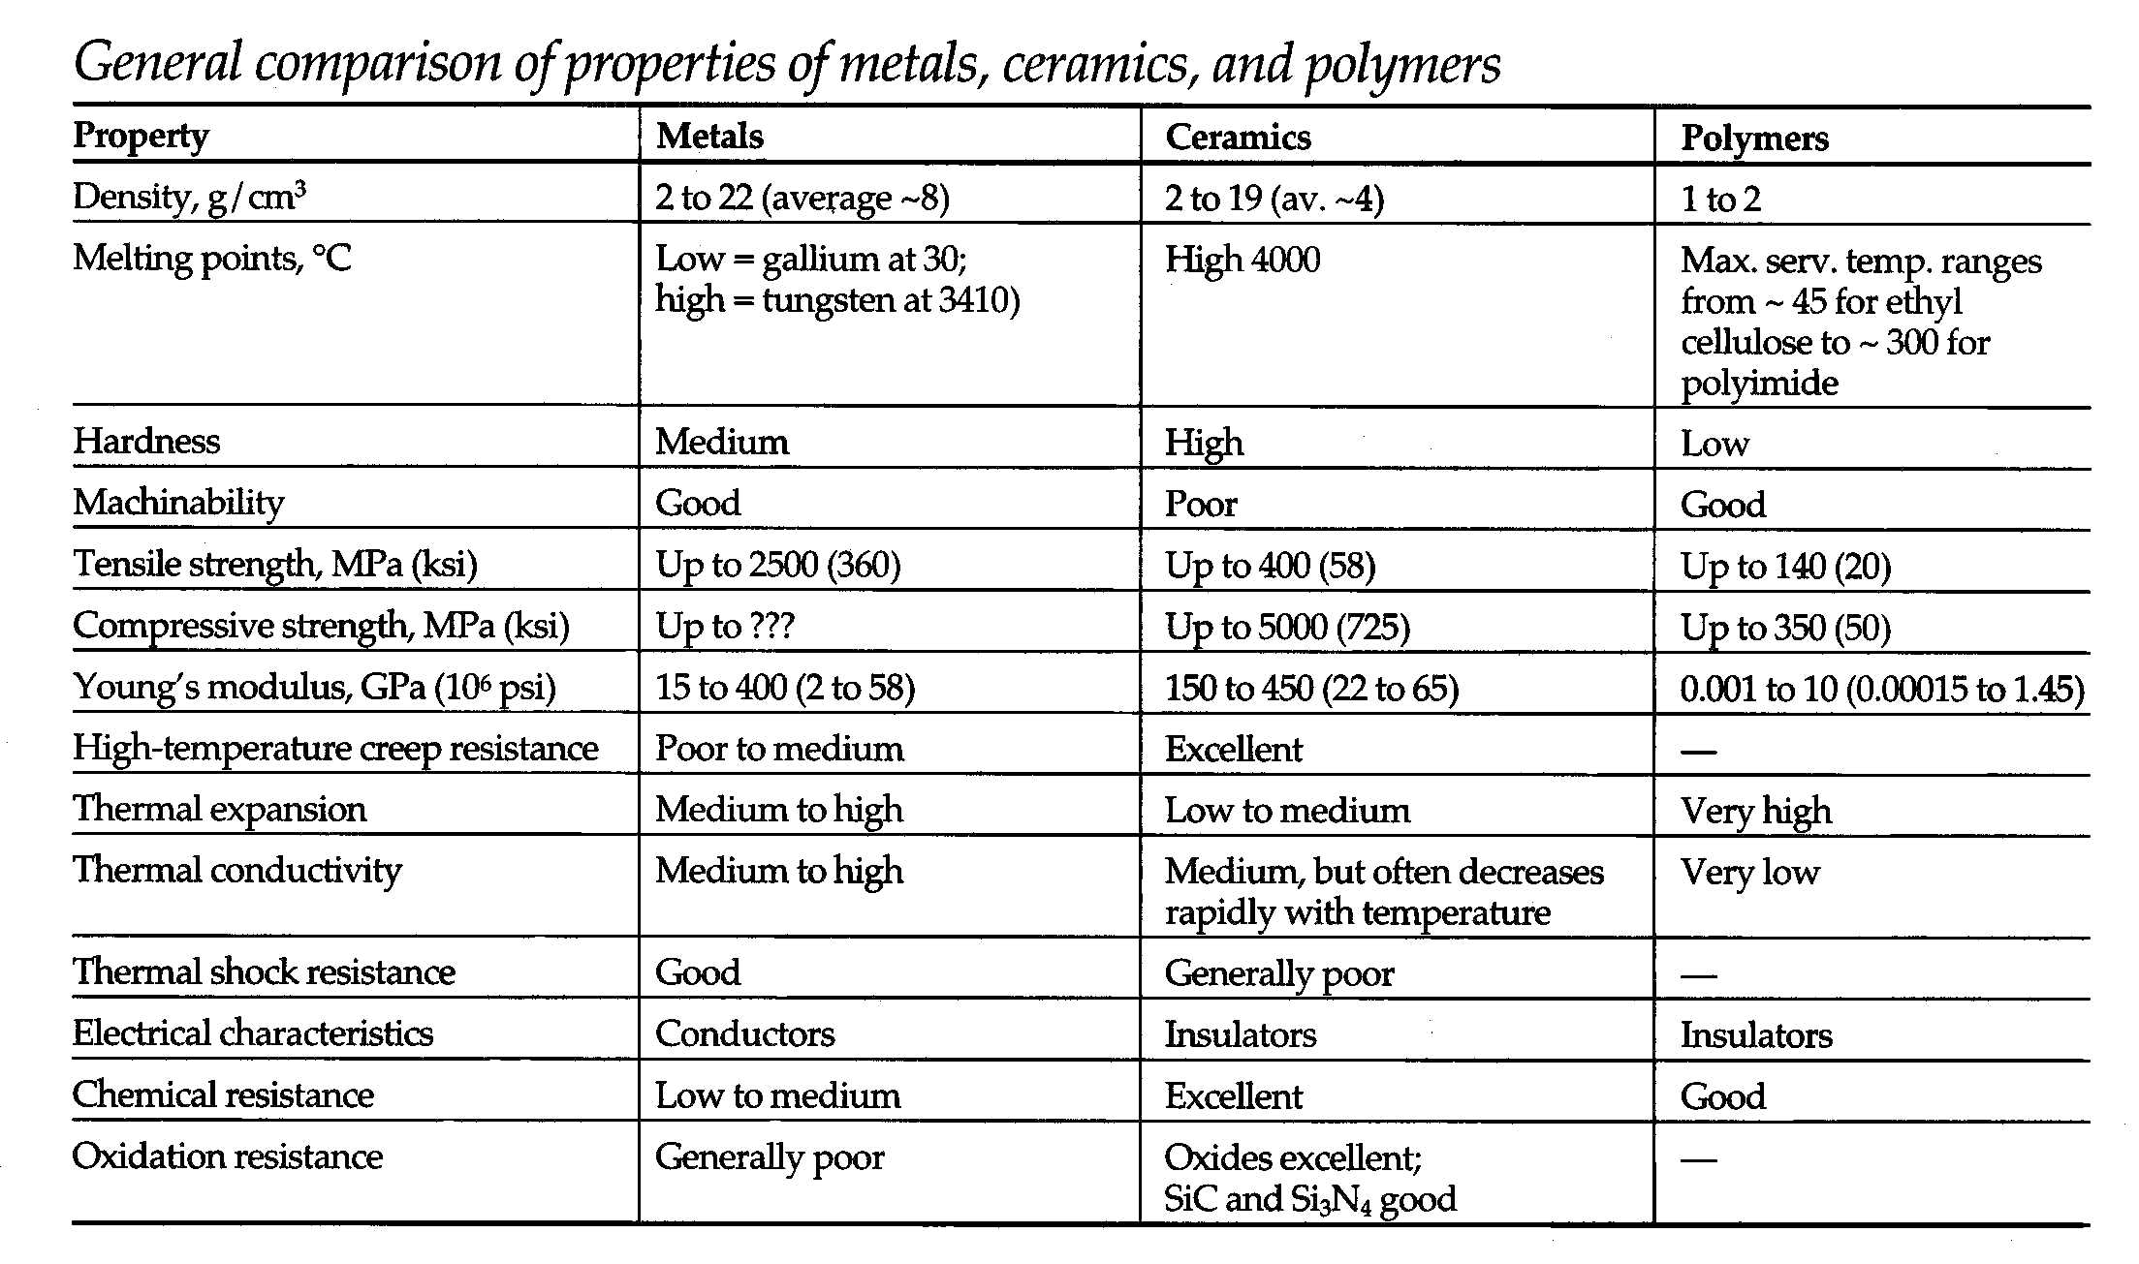

Pre-Test

This will NOT be graded, but instead used for two purposes: First, to provide the instructor with a general feel for your background and current level of understanding of some fundamental materials selection/design concepts. We will revisit some of these questions during the semester. Second, to cross-check enrollment records provided by the University -- so please make sure your name is printed neatly on the appropriate line.

Don’t worry if you can’t answer some of the questions today; by the end of the semester, you should have a good understanding of these concepts.

Please make your answers brief (Brevity is the hallmark of science & engineering!)

Place your responses in the box when you exit the room.

